

**{Conversion}**

**Intermediate page after list**

**OSK 20110617 / PPM 225**

**Specifications**

**V1.1**

|  |  |  |  |
| --- | --- | --- | --- |
| Version | Date | Owner | Modification |
| 0.2 | 11/09 | Julie Prieur | Initialization |
| 1.0 | 12/26 | S Davoise | New specs format + Use Cases description |
| 1.1 | 01/04 | S Davoise | Wink list cases |
|  |  |  |  |
|  |  |  |  |
|  |  |  |  |
|  |  |  |  |
|  |  |  |  |

**Summary**

1 Introduction 3

1.1 Context & Objectives 3

1.2 Perimeter 3

2 Project description 4

2.1 General description 4

2.2 Feature 1: Access to Visit List 4

2.2.1 Keys points 4

2.2.2 Existing feature (As-Is) 5

2.2.3 Targeted feature (To-Be) 6

2.3 Feature 2: Access to Wink List 7

2.3.1 Keys points 7

2.3.2 Existing feature (As-Is) 8

2.3.3 Targeted feature (To-Be) 9

2.4 Design 10

2.4.1 Layer Description 10

2.4.2 Fake list description 10

2.4.3 Maquettes 11

3 KPIs, Testing & Reporting 12

3.1 KPIs to monitor 12

3.1.1 Metrics 12

3.1.2 Dimensions 12

3.1.3 Filters 12

3.1.4 Frequency of analysis 12

3.1.5 Analytics validation 12

3.2 A/B testing 12

3.3 Constraints & Risks 13

5 Teams impacted 14

5.1 Mobile 14

5.2 Payment 14

5.3 CRM 14

5.4 Biz Dev 14

5.5 International Operation 14

5.6 Brand 14

5.7 Customer care 14

5.8 Back-offices 15

5.9 Legal 15

6 Countries Parameters 15

6.1 Parameters 15

6.2 Translations 15

7 User acceptance 15

8 Appendices 16

# Introduction

## Context & Objectives

Today, when a non-sub member clicks on « Visit list » he is redirected to payment page. Once on payment page, the message (“message variabilisé”) is not very visible and might not be very incentive.

Consequently, the member does not know why he landed on payment page and might found it a little aggressive.

We would like to test adding a new page between Visit List and Payment page. This page will give the member some information on profiles who visited him to incite him to pay to learn more.

This feature will be generalized on all lists which are paying features.

The main objective is to increase conversion.

## Perimeter

Target: All sites

For launch, the feature will be activated only on meetic.fr (AB test) and for visit list.

# Project description

## General description

We will have 2 different pages:

* Page 1: Total number of visits or winks received + CTA payment page (different regarding the gender)
* Page 2: Empty state + CTA Daily 6

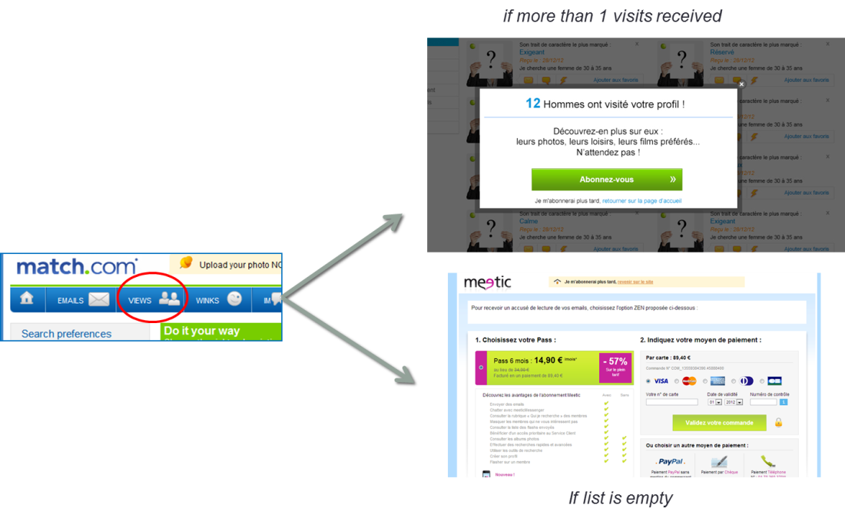

## Feature 1: Access to Visit List

### Keys points

The feature is based on the existing eco model.

User has or not access to lists. It depends on the country and the KvK

|  |  |  |  |
| --- | --- | --- | --- |
| **Access?** | *Sub* | *Non-Sub MW* | *Non-Sub WM* |
| *Latin countries (FR, SP, IT)* | YES | NO | YES |
| *Nordics countries (UK, SE, FI, NO, DK, NL, DE)* | YES | NO | NO |

### Existing feature (As-Is)

Today, 2 cases exist:

* The user have rights to access so he goes on visit list
* The user haven’t rights to access so he is redirected to payment page



### Targeted feature (To-Be)

For the new feature, the 2 cases exist too and one is added:

* The user have rights to access so he goes on visit list
* The user haven’t rights to access so
  + He received some visits so a layer is displayed above a fake list
  + He receives no visit so he is redirected to payment page



## Feature 2: Access to Wink List

### Keys points

The feature is based on the existing eco model.

User has or not access to lists. It depends on the country and the KvK

|  |  |  |  |
| --- | --- | --- | --- |
| **Access?** | *Sub* | *Non-Sub MW* | *Non-Sub WM* |
| *Latin countries (FR, SP, IT)* | YES | NO | YES |
| *Nordics countries (UK, SE, FI, NO, DK, NL, DE)* | YES | NO | NO |

### Existing feature (As-Is)

Today, 2 cases exist:

* The user have rights to access so he goes on wink list
* The user haven’t rights to access so he is redirected to payment page



### Targeted feature (To-Be)

For the new feature, the 2 cases exist too and one is added:

* The user have rights to access so he goes on wink list
* The user haven’t rights to access so
  + He received some winks so a layer is displayed above a fake list
  + He receives no wink so he is redirected to payment page



## Design

### Layer Description

The intermediate page is composed by a layer and a “fake” list of profile.

The layer shows the total amount of visit or wink received. This number will be exactly the same as the number in the header counter and will correspond to the number of profile in the visit list or wink list.

Display of this “intermediate page” will not reset the counter in the header.

Add an action code on the layer to be able to track the performance of the layer.

For visit case, the « Message variabilisé » will be *“Pour découvrir qui s'intéresse à vous, choisissez l'un des abonnements proposés ci-dessous »* actually used on the site, corresponding to the existing wording : « 34 - VOIR VISITEURS »

For wink case, the « Message variabilisé » corresponding to the existing wording: « 33- FLASHER »Haut du formulaire

Haut du formulaire

The layer is like that:

*(this moke up is for visit case)*

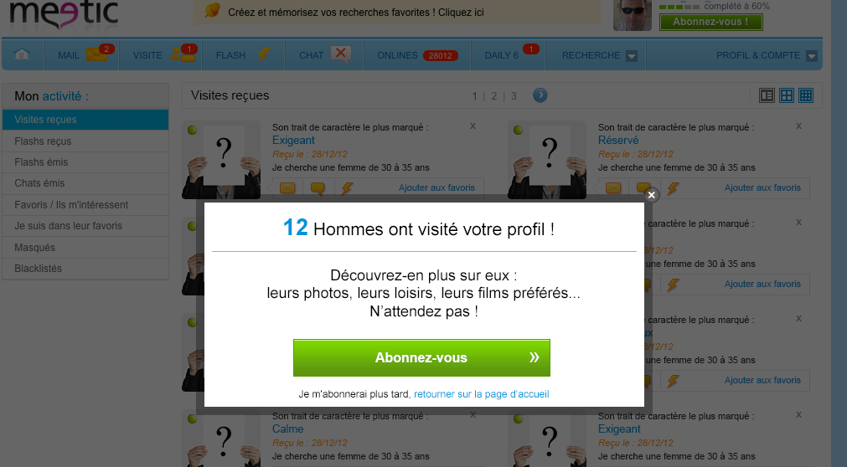

### Fake list description

The intermediate page is composed by a layer and a “fake” list of profile.

The “fake list is under the layer



Display the first profiles of the list, maximum 12.

Display the profiles of the list but:

* Hide the picture, replace it by women or man holding a sign.
* Display the personality
* Display the date when the activity was received
* Display the age range of the search
* Display the communication tool bar

If the field is empty display “je le garde pour moi”.

Every profils is like that:

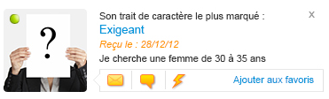

### Maquettes

*Path for maquettes :* \partage\Design\MEETIC_V7\03_List\Intermediate-page

# KPIs, Testing & Reporting

## KPIs to monitor

### Metrics

Number of display of this intermediate page

Performance of the new action code (Number of pass bought / number of display coming from visit or wink list / conversion rate)

Objective is to check that we have a better conversion in the test group.

Tracking : be abble to track how many time this page was displayed.

### Dimensions

N/A

*It’s a sort, when you choose a dimension the information is sorted but stays available.*

*I.e.: age, channel, registration date (day/month/week), sub date, gender*

### Filters

N/A

*It’s a specific* *criterion. For example:*

*- Fraud adjusted: the analysis will be only on non-scammers members.*

*- Period to analysis*

### Frequency of analysis

N/A

*Every day/ one per week*

### Analytics validation

N/A

*Name of the person who validated this part and date of the validation*

*Frequency of analysis: everyday / one per week*

## A/B testing

A/B test required.

Meetic France 50%

## Constraints & Risks

N/A

* *Constraints: For example retest all the smart landing*
* *Risks : Possibility of regression, functional and technical degradation*

*For example: this project can break all the super tracking or for the optimization of the selfest possible impacts on matchlist and personality report.*

# Teams impacted

## Mobile

N/A: this project is a Desktop projet

*Adaptation of the feature on the mobile platform.*

## Payment

Creation of a new Operation Code

Duplicate the existing “message variabilisé” for visit list (34)

Duplicate the existing “message variabilisé” for wink list (33)

*Creation of action code, variable messages*

## CRM

N/A

*Impact on email (to create or modify)*

## Biz Dev

N/A

*SEM: e.g. redirection of site all the impacts of Keywords*

*SEO: reuse existing tags*

*Affiliation: creation of marketing codes, affiliation campaigns*

## International Operation

N/A

*Impact on HPV*

*Impact on landing and non-logged pages*

## Brand

N/A

*Impact on brand content*

*E.g.: new Meetic, CMS*

## Customer care

N/A

*Updates to FAQ*

*Impacts on CC advisors*

## Back-offices

N/A

*Impacts to OBO, Events Back-office, SpotBO, AB Testing Backoffice*

## Legal

N/A

*Legal terms in Terms and Conditions page*

*Information about cookies*

# Countries Parameters

## Parameters

N/A

*Indicate here if the project needs to be adapted to different economic models*

## Translations

Excel file is delivered to Product Team to have translation for Development

*Only for small translation, for big project you need an Excel file*

# User acceptance

Access to visit list:

* A paying user has access to visit list
* An unpaying user WM on latin site has access to visit list

Access to fake visit list with layer:

* An unpaying user MW with at least one visit hasn’t access to visit list and goes to the fake visit page with layer
* An unpaying user WM on no latin site, with at least one visit hasn’t access to visit list and goes to the fake visit page with layer
* An unpaying user MM with at least one visit hasn’t access to visit list and goes to the fake visit page with layer
* An unpaying user WW with at least one visit hasn’t access to visit list and goes to the fake visit page with layer

Access to payment page:

* An unpaying user MW with no visit hasn’t access to visit list and goes to the fake visit page with layer and goes to payment page
* An unpaying user WM on no latin site, with no visit hasn’t access to visit list and goes to payment page
* An unpaying user MM with no visit hasn’t access to visit list and goes to the fake visit page with layer and goes to payment page
* An unpaying user WW with no visit hasn’t access to visit list and goes to the fake visit page with layer and goes to payment page

Access to wink list:

* A paying user has access to wink list
* An unpaying user WM on latin site has access to wink list

Access to fake wink list with layer:

* An unpaying user MW with at least one wink hasn’t access to wink list and goes to the fake wink page with layer
* An unpaying user WM on no latin site, with at least one wink hasn’t access to wink list and goes to the fake wink page with layer
* An unpaying user MM with at least one wink hasn’t access to wink list and goes to the fake wink page with layer
* An unpaying user WW with at least one wink hasn’t access to wink list and goes to the fake wink page with layer

Access to payment page:

* An unpaying user MW with no wink hasn’t access to wink list and goes to the fake wink page with layer and goes to payment page
* An unpaying user WM on no latin site, with no wink hasn’t access to wink list and goes to payment page
* An unpaying user MM with no wink hasn’t access to wink list and goes to the fake wink page with layer and goes to payment page
* An unpaying user WW with no wink hasn’t access to wink list and goes to the fake wink page with layer and goes to payment page

# Appendices

*Put links of useful documents on the share drive: technical specs, mock-up, translations…*